January 2017 PTA Newsletter
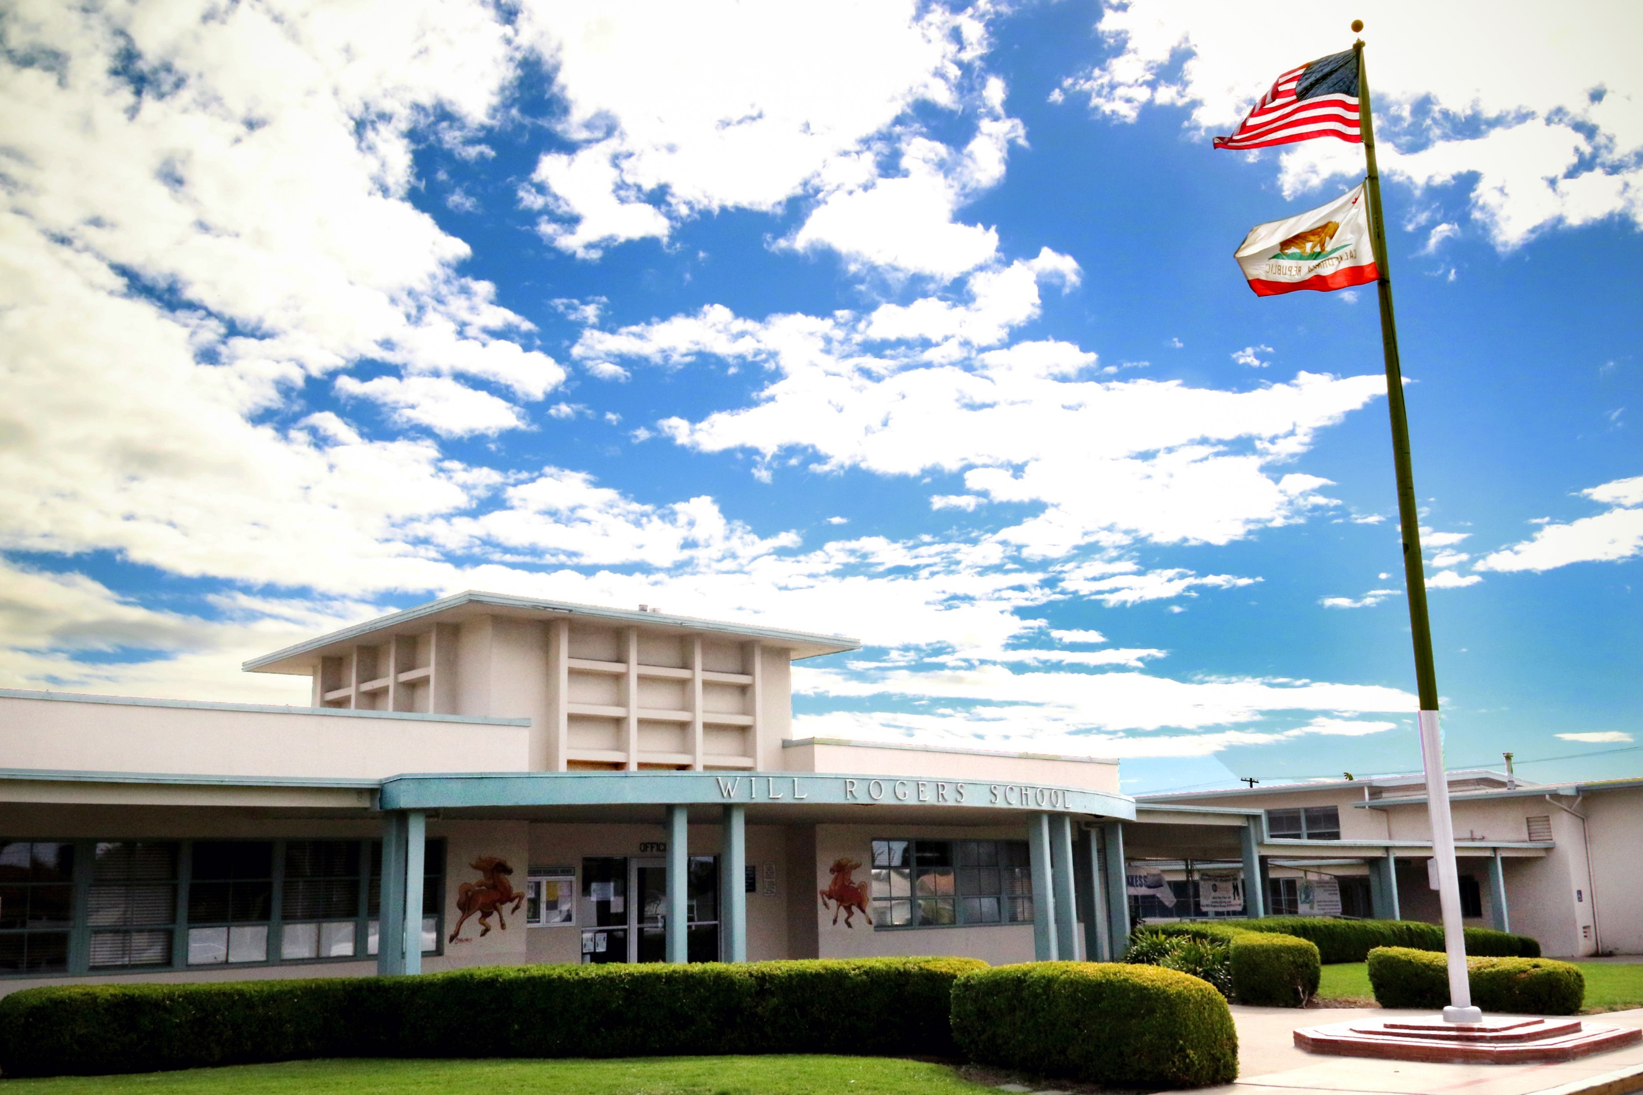

Upcoming Events

January 10

Sky Zone Jump Night 4-8pm

January 12

New West Music Van Assembly

January 13 and 27

Book Exchange 7:20-7:55am

January 20

School of Choice Application Due by 4pm

January 28

C-St Beach Clean Up (by pier) 9-11am
Calling all business owners or friends of business owners! We need donations of goods, services, and gift cards for our Spring Carnival!
Jump to raise money for Will Rogers!

C St. Beach Clean Up Day
January 28 – C. St/Surfer’s Point, 9-11am We’ve teamed up with Surfrider Foundation for a volunteer opportunity to clean up our beaches! All volunteers must sign a liability waiver (see WR website) and anyone under 18 needs adult supervision! RSVP required - please email Julie at jsalomonson@yahoo.com or (805) 437-1847.

si
https://www.facebook.com/groups/WillRogersElementaryPTA
Welcome back and Happy New Year!

Sky Zone Will Rogers Jump Night! January 10, 4-8pm
Need to burn some energy? Come to Sky Zone on Tuesday, January 10th, from 4-8pm! Will Rogers and Lincoln Elementary are partnering up to raise money for our schools! A proceed of your admission fee will come back to Will Rogers. Prices start at $5 per jumper for 30 minutes! Please be on the look-out for a flyer in your child(ren)’s backpack!

New West Symphony Music Van Assembly! Parent Volunteers are Needed! Can You Help?
On Thursday, January 12th, and Friday, January 13th, New West Symphony will be supporting our music program and providing a hands on learning opportunity to our 3rd and 5th graders! Of course, parent volunteers are needed to ensure a smooth experience for all of our participating students. Please contact Rachel McClanahan at (805) 794-0515 or email at Rach.McClan@gmail.com if you are available to give your time. Find out more about New West Symphony and their music van visit https://newwestsymphony.org
Pen Pal Program with Sister City Loreto, Mexico
Did you know that our 3rd-5th graders have been participating in a pen pal exchange with our sister city in Loreto, Mexico? Our students recently received letters before Winter Break and are writing back! Two of our teachers, Mr. Maxwell and Mr. Pinedo are visiting our sister school in Loredo this month to personally deliver more letters! We wish them a safe trip!
School of Choice – Application Deadline January 20th at 4pm!
The School of Choice window is January 6th – 20th! If you are not a boundary area student, please apply for Will Rogers during this time. All incoming siblings also need to apply! Applications can be picked up at the school office or found online at www.venturausd.org. Please spread the word!

